Beyond Change:

REFRAME Organisational Adaptation

Change is not a process – It is a mindset.

Most current change models approach change using process models (ADKAR, Kotter etc.), focused on a logical sequence of stages to provide relevant information to impacted stakeholders.
But change is not a logical cognitive process
that occurs within a vacuum.

Effective change requires an understanding of the lifecycle of organisations, the underlying causes of change, the influence of culture, and the emotional stages individuals go through when they experience significant transformation. Underestimating the influence of these deep-seated underlying factors on the change process is one reason up to 70% of change programs fail.

Change is not a process - it is a mindset.

Our REFRAME change management model places people at the heart of change; not simply supporting employees to cope with change but developing self-efficacy for change to actively adapt and manage change within the workforce. To succeed into the future organisations must be adaptable, agile and proactive. Change is inevitable and the workforce must not just be resilient in the face of change, they must embrace the potential for change.
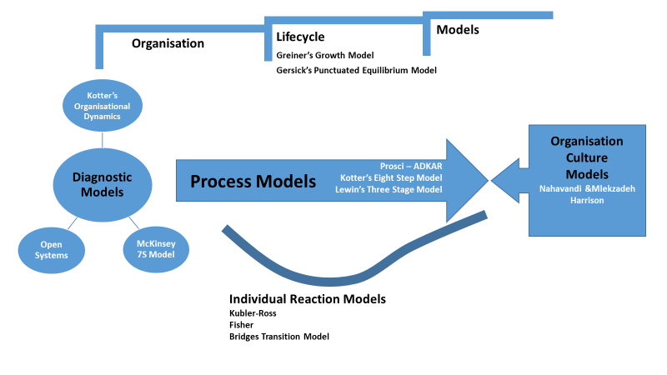
https://www.slideshare.net/AndreDegreefFAHRI/change-management-models-in-context?from_action=save

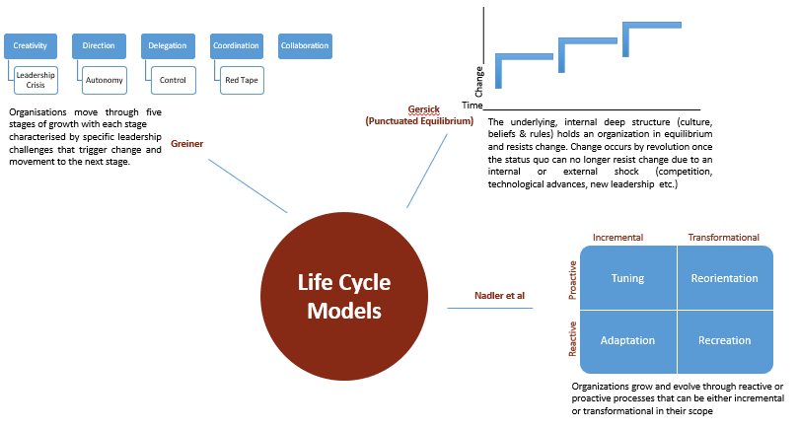
This is where an understanding of organisational lifecycle models of change may support more effective and lasting change. Lifecycle or evolution models (including classic theories such as Gersick and Greiner) posit that organizations grow and evolve through stages of stability and change, and that all process change and business transformation occurs within the context of this growth and evolution. These models focus on the overarching consideration of the strategic issues of growth and development; they set the scene in relation to understanding where an organization is at in its development and what drivers for change (interrnal and external) may exist at that stage. These models describe how organizations change over time.

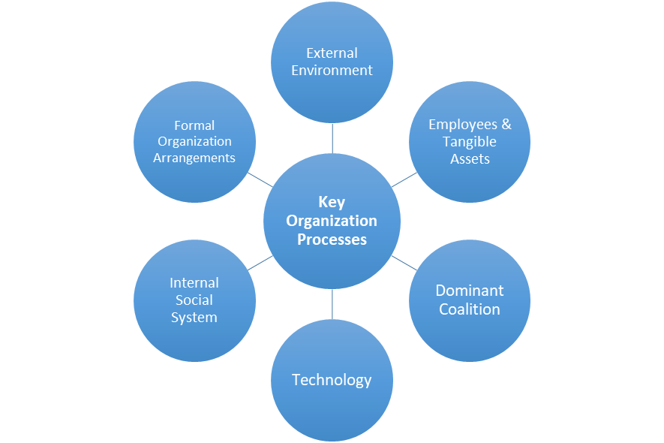
Diagnostic models (such as Kotter's Organizational Dynamics, Systems Theory and McKinsey's 7S model) may offer insights into where to target change processes. These models focus on analysis and diagnosis of the underlying problems. Change and organizational leaders must take a closer look at the components and dynamics of an organization and their interactions with each other and the external environment, not just at a point in time but over the short, medium and long term, to identify both immediate issues and trends. These theories focus on identifying the interactions and cause/effect relationships
between people, structures, systems and processes within an organization and, in particular, diagnosing the currently dysfunctional or misaligned factors or relationships (or those at risk of future misalignment) within the enterprise and its environment.

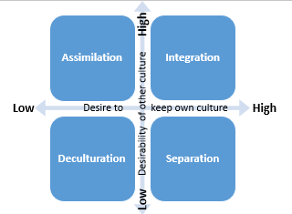
A core component most of these diagnostic models is the organizational culture, and a number of theories take this one step further. Cultural Models essentially propose that 'organizations are culture’, and that the considerations of aligning change strategies to the existing culture of the organization (and the culture of individual groups affected) is the key to success. These models promote understanding the relative value of one's own culture compared to the attractiveness of taking on a new organization culture during transition (particularly mergers), as well as considering issues such as the connectedness and uniformity of the culture (or subcultures) and the level of formalization and centralisation in an organization. All of which may influence the success of a change program.

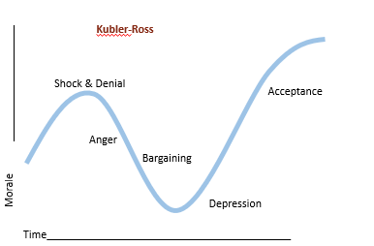
Finally, leaders of change processes need to have an understanding of individual and group emotions. While many change and project management models include a "people side" there is, nevertheless, an underlying assumption of rationality in the activities and messages delivered and that people will 'think their way through change'.
The reality is, most people will feel their way through change,
so individual reaction or transition models are helpful for change managers to identify the potential journey change recipients may undertake during a change process. Having an awareness of the broad stages of transition and the feelings and blockages they may experience during that journey may support more effective communication and action.

Our REFRAME model identifies four core stages of organisational development and transition.

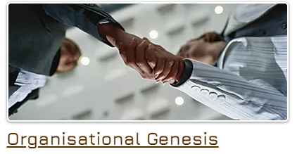
Some of the greatest change comes when new organisations, divisions or teams are established and begin growing. Tuckman's 1965 model of forming, storming and norming still holds true. Establishing core values, culture and performance expectations are vital in determining how organisations face the challenges of the future.

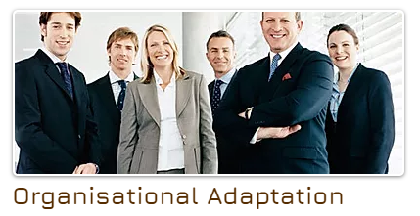
Changing processes and systems is easy, changing people is not. ​Organisations have to prepare staff to face change and their managers to lead change; and they need to develop the capability now to adapt and prosper in a changing future of work.

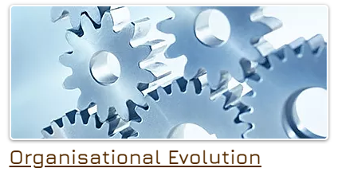
Never before have organisations had to continually adapt and evolve to their environment the way they do now. Adaptability,. emotional intelligence and change efficacy are vital, not just for your people, but for your organisation as a whole. Continuous culture change and process redesign and organisational evolution are vital in the changing world all organisations will face into the future.

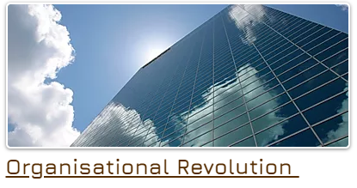
There comes a point in every organisations lilfe-cycle where the incremental development and change brought about by organisational adaptation and evolution are no longer enough and significant organisational transformation is required, Organisational restructures and downsizing processes can be one of the most traumatic events employees can face in their career, and are very often traumatic for the organisation as whole, long after they are completed.

While the REFRAME change steps are the same for each type of change, the specific processes for each may differ. The approach you take to operationalizing the steps must take into account the organisation’s lifecycle stage, the issues it faces, its culture and the potential impact change will have on individual employees.

The REFRAME model offers an emotionally intelligent change framework and recognizes that change is an inherently emotional process, not a rational cognitive one.

Most people don’t fear change, they fear disadvantage or loss as a result of the change

Recognise
- Identify the vision and purpose for the change
- Understand the why and how the change, including the organization’s evolution and history
- Recognise the fear individual emotions change can create
- Identify the cultural artefacts in relation to change ​

Engage
- Communicate the high-level vision, purpose and strategy
- Define the roles and performance expectations for the implementation team and employees
- Identify transformation steps, change owners and networks , key messages
- Acknowledge the fear, resistance and the emotional change journey employees will face
- Establish relationships and networks for collaborative dialogue and implementation

Frame
- Frame the implementation journey at the strategic level
- Provide details of specific activity, roles and duties
- Preempt and respond to areas of concern , resistance and risk among employees
- Establish and explain team and individual performance measures and success indicators

Resource
- Develop necessary policy, procedures and governance structures, processes and tools
- Build organisational adaptability, leadership capability and technical capability
- Support leaders to be visible and active promoters of new structures, processes and roles
- Establish leadership and business coaches to assist managers and employees

Act
- Implement the necessary business structures and processes
- Reinforce, reward and promote positive behaviours and process change

Measure
- Establish, measure and report on new strategy and employee KPIs
- Monitor and respond to employee wellbeing during change
- Review and revise change processes as required

Evolve
- Prepare your people for organisational adaptation
- Never lose sight of the need for organisational evolution

​

Change is not a process - it is a mindset.

Effective change comes from an adaptable mindset, both at the organisational and individual level. A mindset focused not on the risks of the present, but the opportunities of the future. This mindset is built on five key change capabilities outlined in the model below.

Change Efficacy (The Foundation)

The belief in one's capabilities to organize and execute the sources of action required to manage change. People who have a sense of self-efficacy bounce back from failure; They approach things in terms of how to handle them rather than worrying about what can go wrong. Change-related self-efficacy can be defined as an employee’s perceived ability to function well on the job, despite the demands of a changing work environment.

Digital Literacy (The Defence)
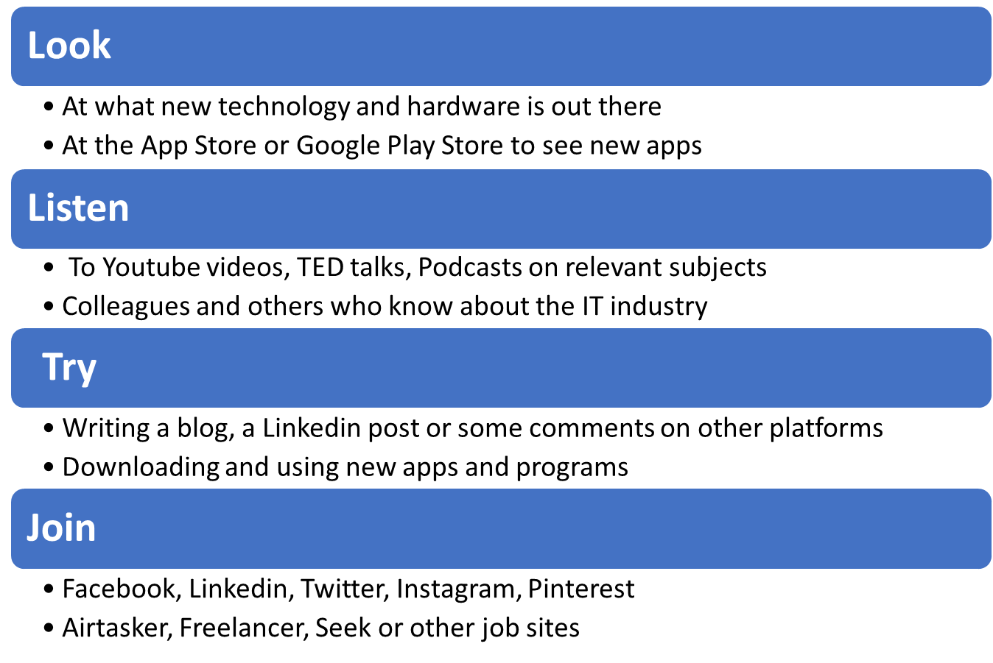

Network Building (The Offence)
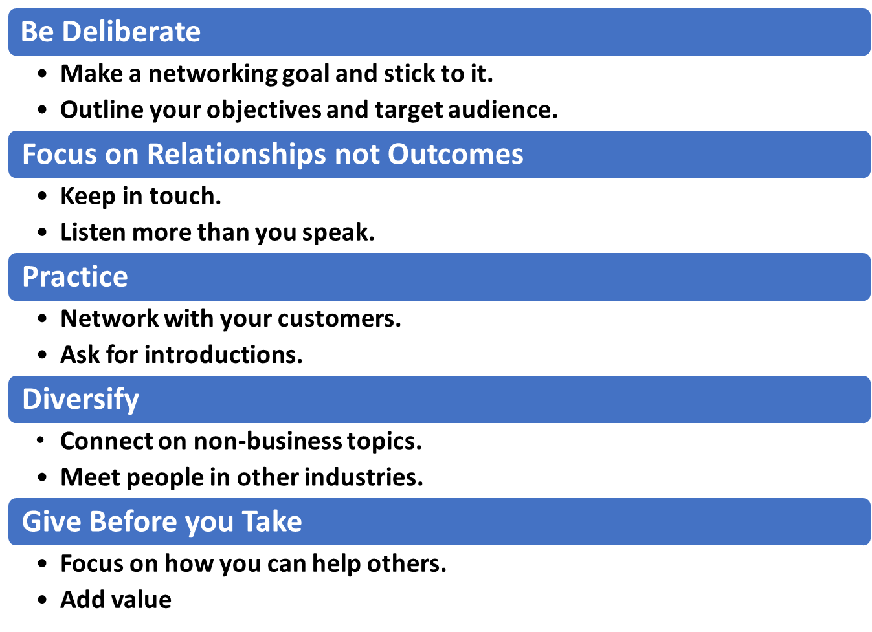

Emotional Intelligence (The Core)
The ability to perceive accurately, appraise, and express emotion; the ability to access and/or generate feelings when they facilitate thought; the ability to understand emotions and emotional knowledge; and the ability to regulate emotions to promote emotional and intellectual growth.

Emotional Intelligence has important benefits during change helping to improve relationships in the workplace, teamwork and conflict resolution, improved communication and greater empathy. It is also the core of the capability model above, being a key driver of success in the other capabilities

Career Adaptability (The Focus)
Career adaptability refers to an employee’s readiness to cope with preparing for and participating in wok and employment as well as dealing with unpredictable adjustments and impacts associated with change in work and work conditions. It includes a focus on the future and future career tasks, including considering and preparing for what may come next by exploring new options, seeking information and taking action to solve current career problems and prepare for the future.

- Change is here to stay – it cannot be avoided; by employees or managers

- Change is more than just a rational process with linear stages that can be planned for with effective thinking. – It is multiple interlinked processes with emotional human reactions at the heart.

- Successful change is built on developing organiational adaptability and individual change efficacy before the change occurs. It is no longer enough to be resilient and see the change though – we must all learn to thrive on change.

- Organisational Adaptation can be built, by focusing on building the five core skills individuals need first.

Contact us to find out more:

www.pyramadis.com

0491 631 845

